

***Girik****Pay* Lagao  
Income Badhao!

## Join India's largest Assisted Banking Network! Download app to register as Merchant.

**CREATE FREE ACCOUNT**

GO>

9999999999

Top of Form

Enter WhatsApp Number

Bottom of Form

### Trusted by 4,00,000+ Dukandar!





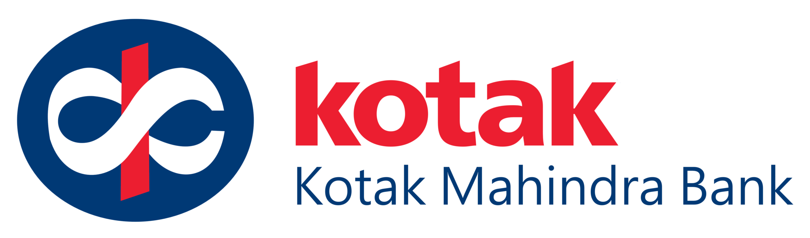



# Offer Digital Banking Services To Your Customers!

### C:\Users\hp\Desktop\finalDigipay\DMT-01.png

### Money Transfer

Send money to any Bank account in minutes and at lowest charges.

### C:\Users\hp\Desktop\finalDigipay\Cash Withdrawal-01.png

### Cash Withdrawal

Provide cash withdrawal service to your customer and highest commission

### C:\Users\hp\Desktop\finalDigipay\Insurance-01.png

### Insurance

Protect your community with medical, health & general insurance.

### C:\Users\hp\Desktop\finalDigipay\Cash Deposit-01.png

### Cash Deposit

Become a bank and accept cash from customers, earn great income.

### C:\Users\hp\Desktop\finalDigipay\Payment Gateway-01 (1).png

### Loans & more...

Avail & provide loans at minimal interest rates, boost your business.

### C:\Users\hp\Desktop\finalDigipay\Mobile Recharge-01.png

### Bill Payments

Accept gas, water, electricity and other 426 Bills at your shop.

## Why *GirikPay*?

## High Commission Fastest Settlement Low Charges

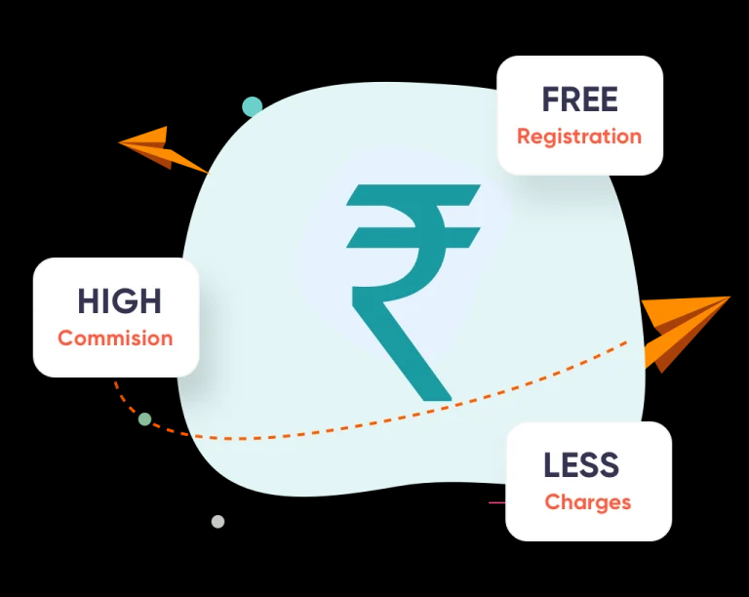

* Free Registration
* 100% Commision on AEPS & MATM
* 0.20% Charges on DMT

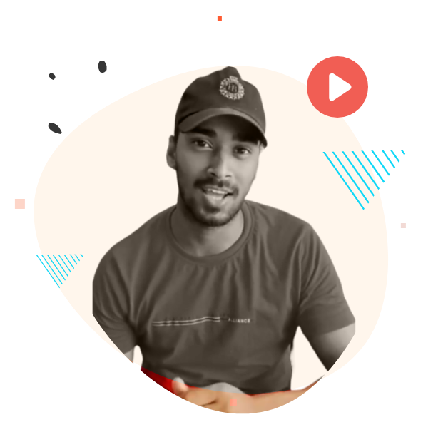



## 

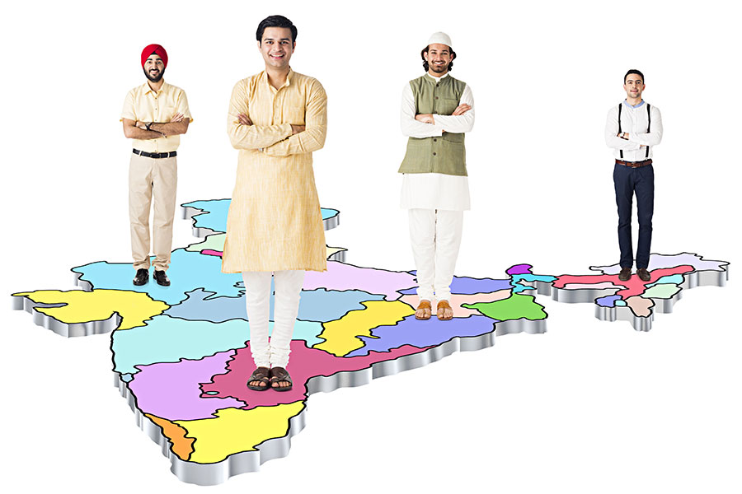

## CONTACT US

Do you need help?  
Reach out to us!

* **care@bharatatm.app**
* **+91 8144 153153**

[Facebook](http://facebook.com/bharatatmofficial) [Twitter](http://twitter.com/bharatatm) [Youtube](https://www.youtube.com/channel/UCtuS1NcMcsoyPyBUWd7WdFg) [Telegram](https://t.me/BharatATMbot) [Whatsapp](http://wa.me/07969033333)

**Made with Love  In Bharat**

Designed by **Finoviti**

## Don't miss the best deals!

Join us on Facebook Messenger and get exclusive updates and discounts.

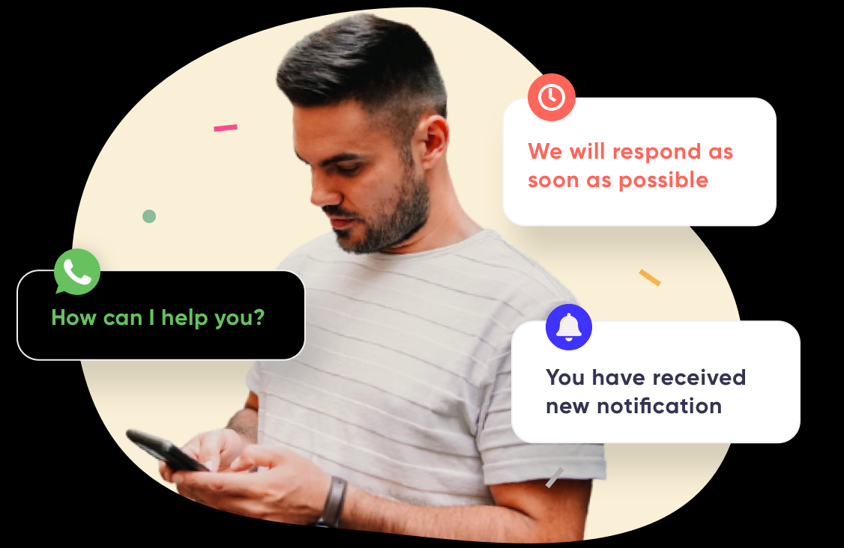

## Award Winning Support

## Chat, Email, Phone & WhatsApp Support

* *Quick response to issues
* * Event based notifications alerts
* * WhatsApp Solution Bot

* ICON

## CONTACT US

Do you need help?  
Reach out to us!

* **care@girikpay.in**
* **+91 7880022295**

 [Twitter](http://twitter.com/bharatatm) [Youtube](https://www.youtube.com/channel/UCtuS1NcMcsoyPyBUWd7WdFg) [Telegram](https://t.me/BharatATMbot) [Whatsapp](http://wa.me/07969033333)